Peter & Zac

3/14/19

A.I.

Remote Controlled Robot

**Importing all necessary assets**

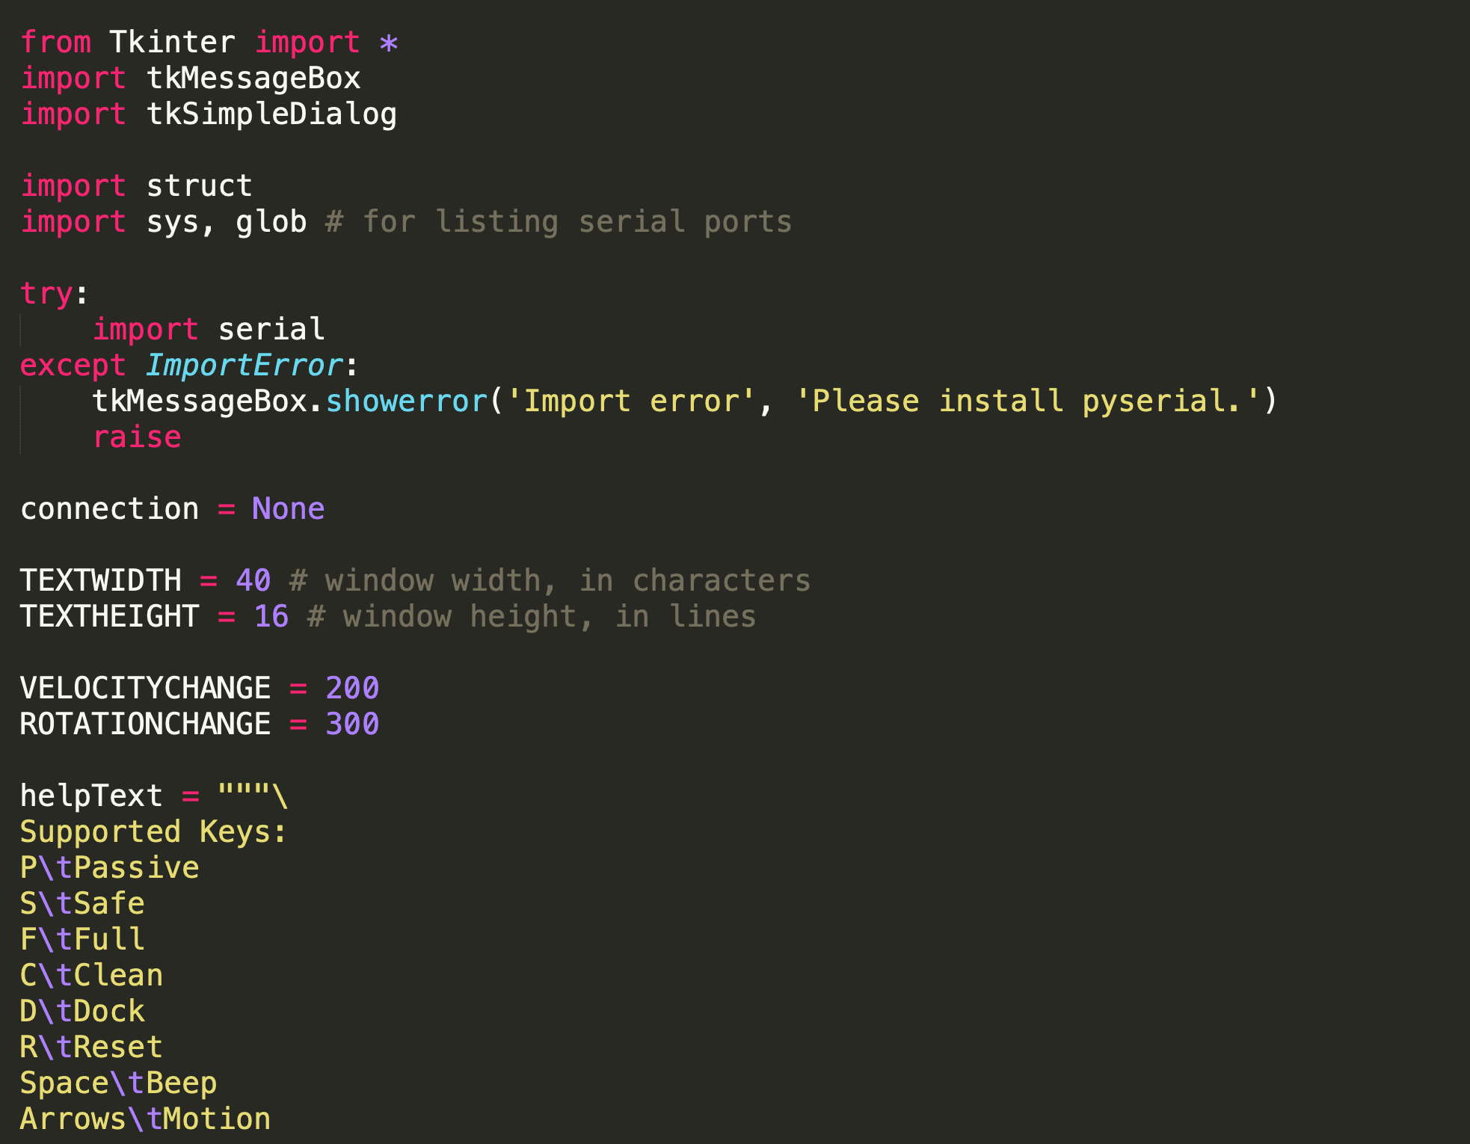

**Building GUI**

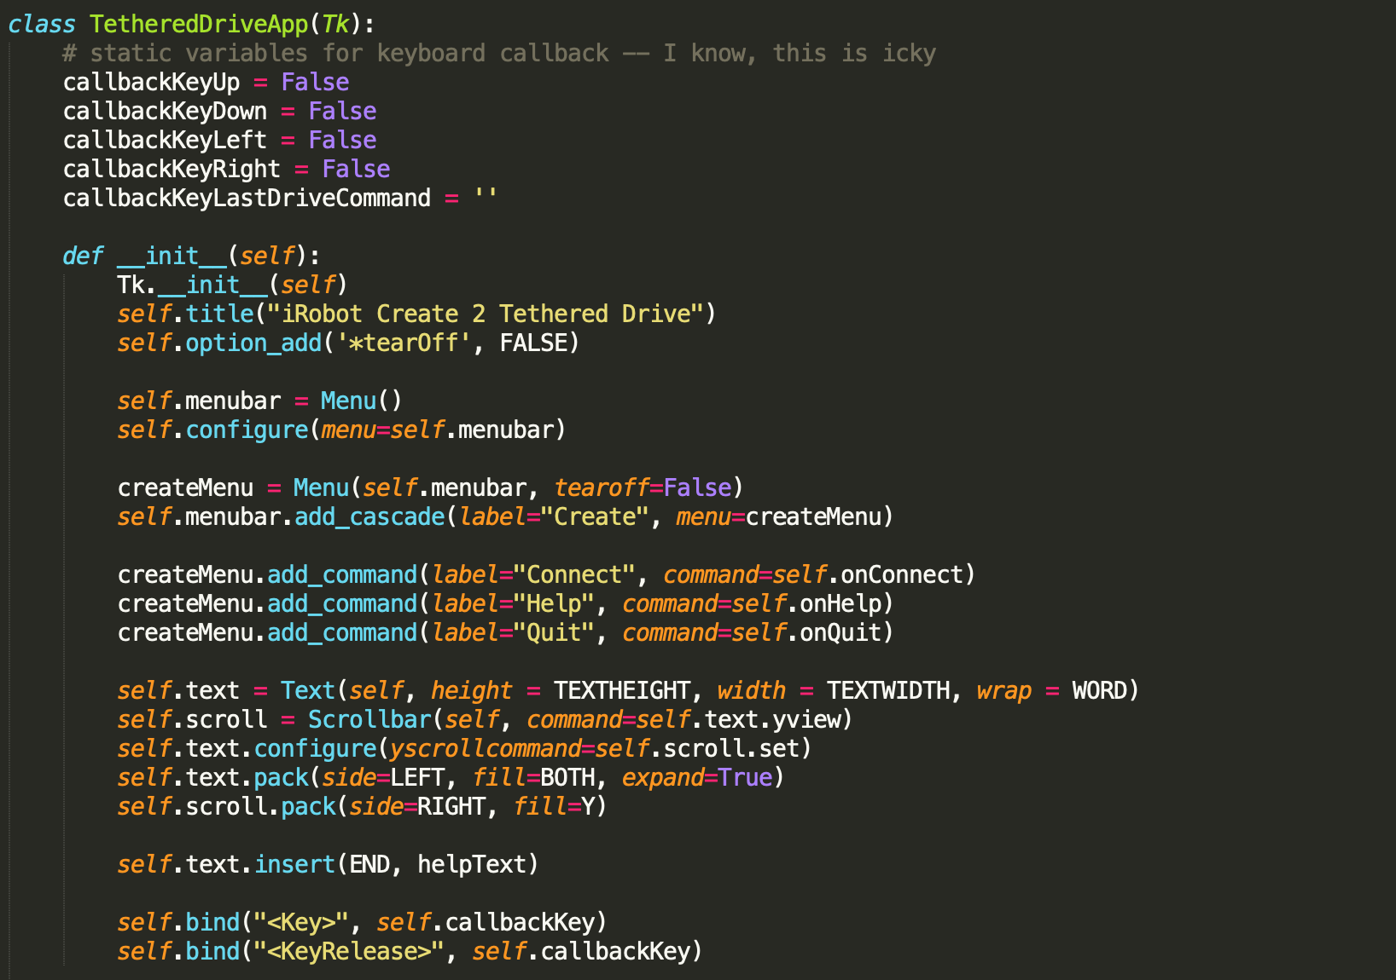

**Conditional statements for GUI output**

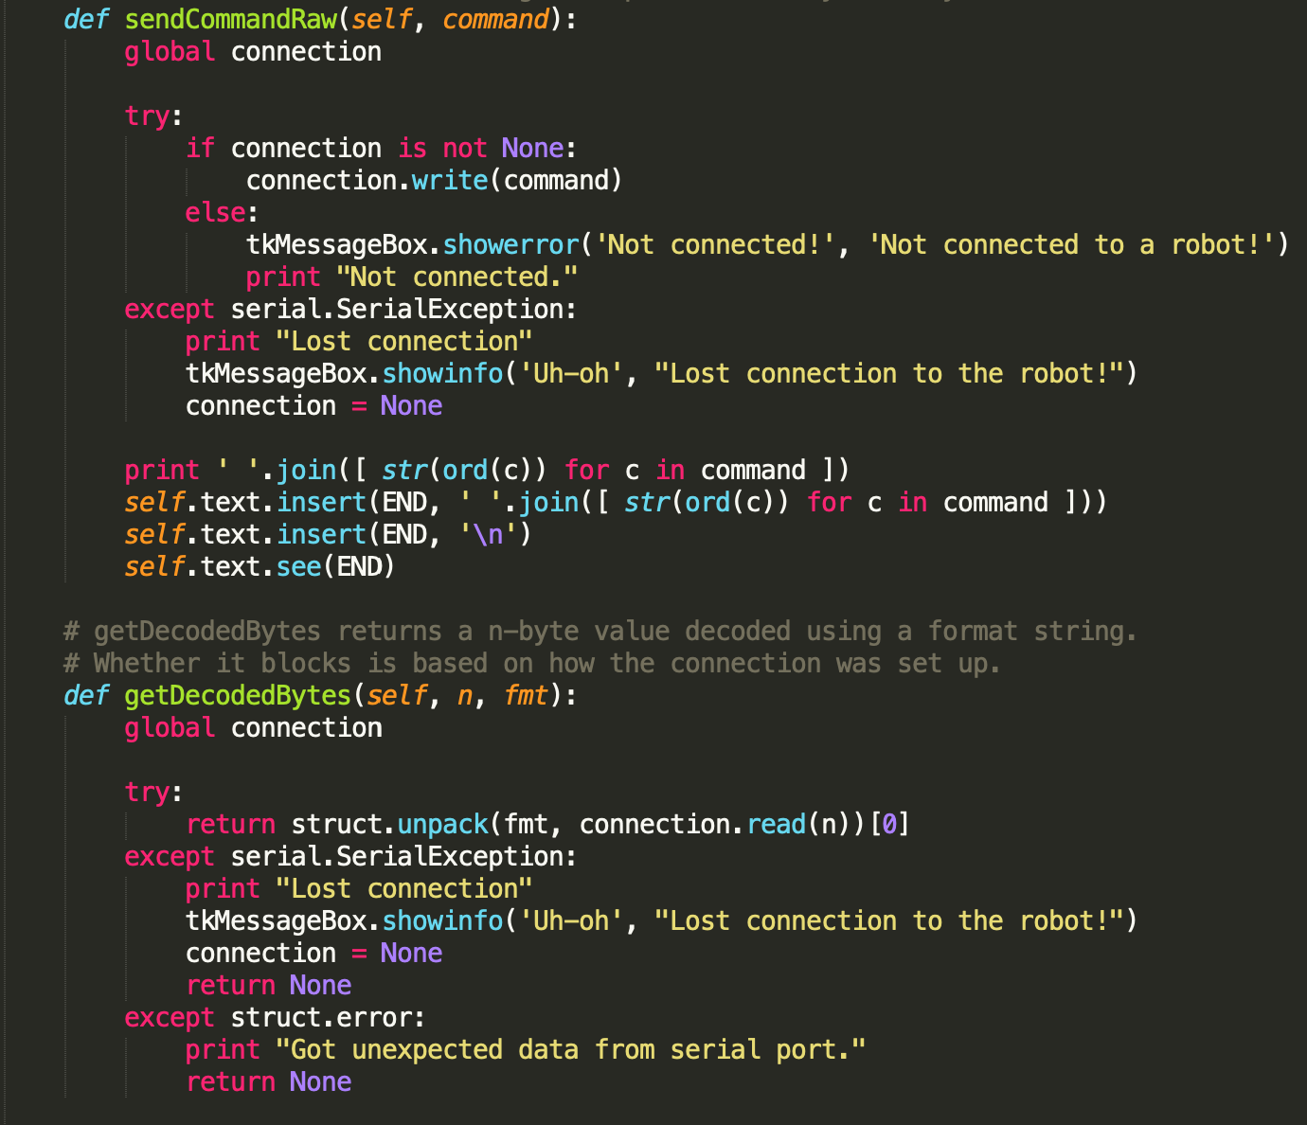

**Handles keypress events for direction & commands**

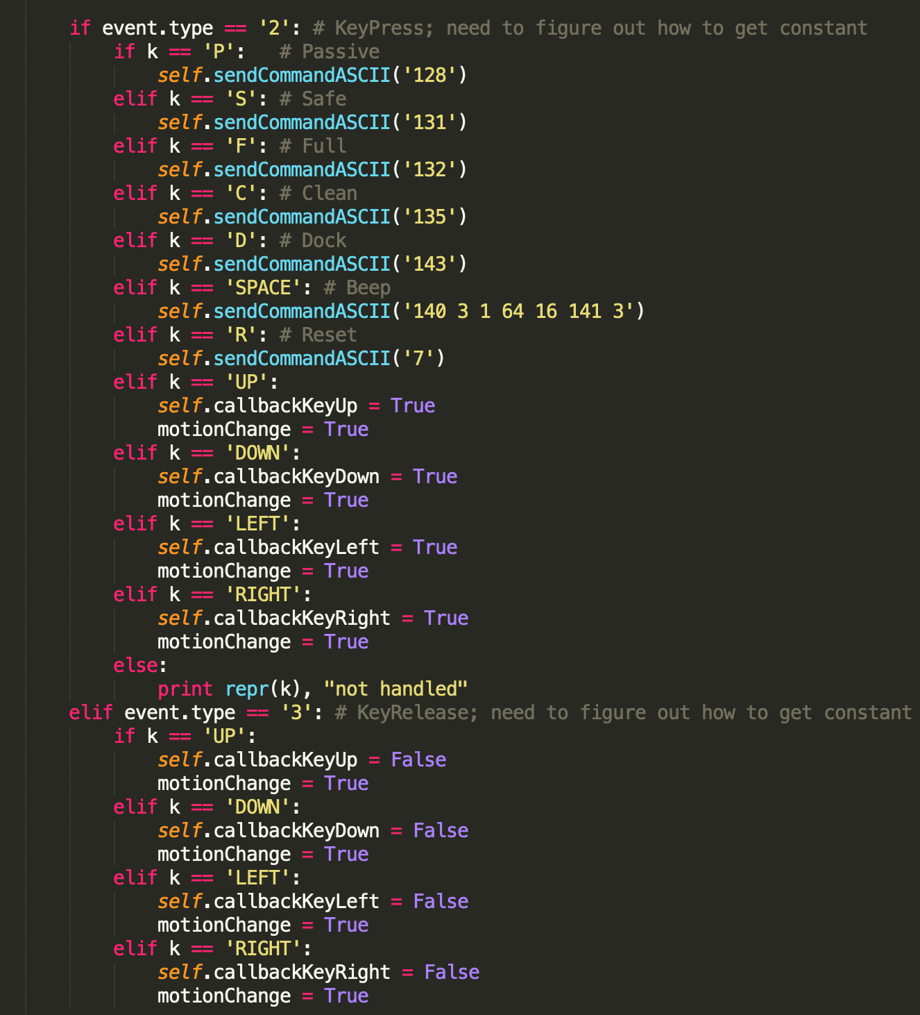

**Handles Port Connection**

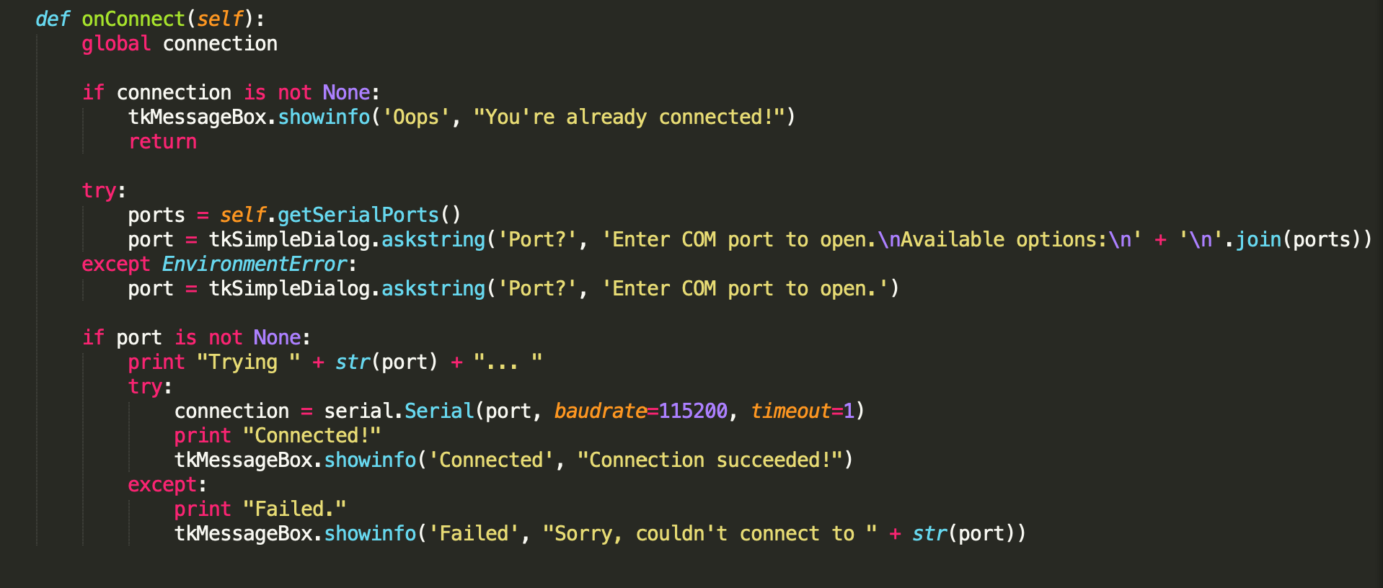

**Conditional statements for handling various operating system ports**

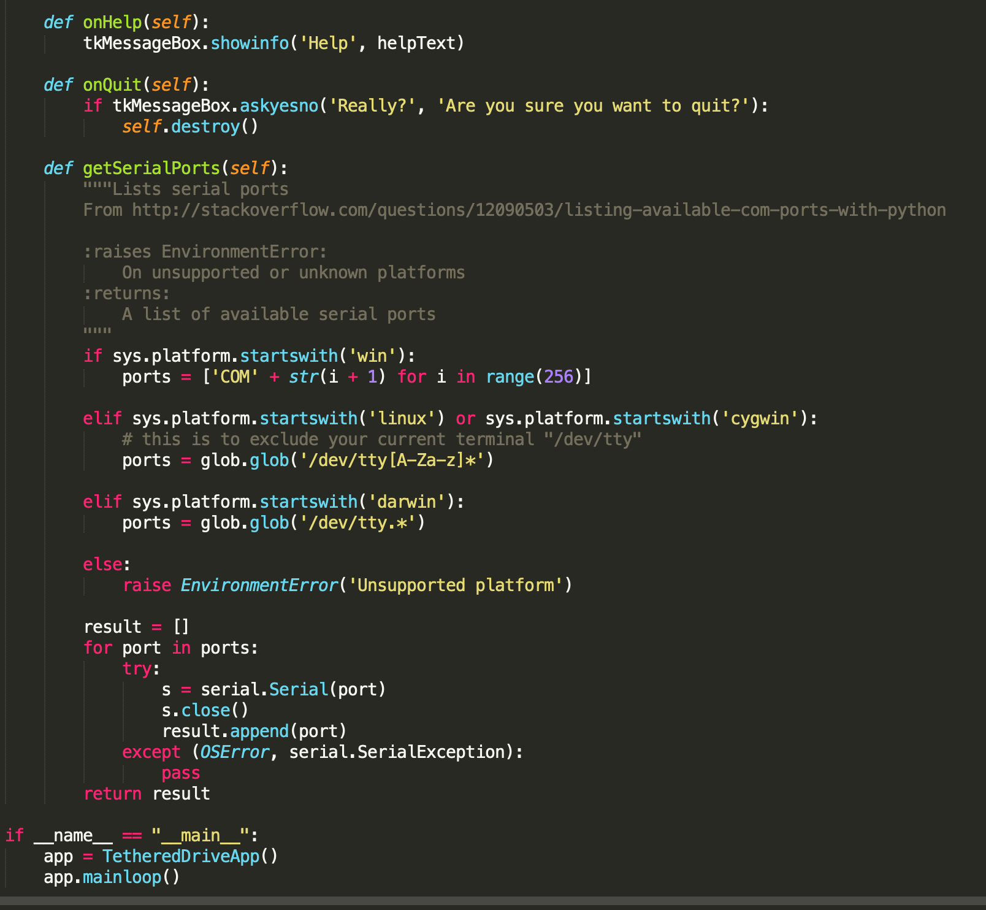

We used a program called xpadder in order to map the controller keys to specific keys on the computer (like the arrows and such). This way the controller passes events to xpadder, then xpadder translates the events to keypress events on the computer which our program then converts to numbers that the IRobot knows as commands.